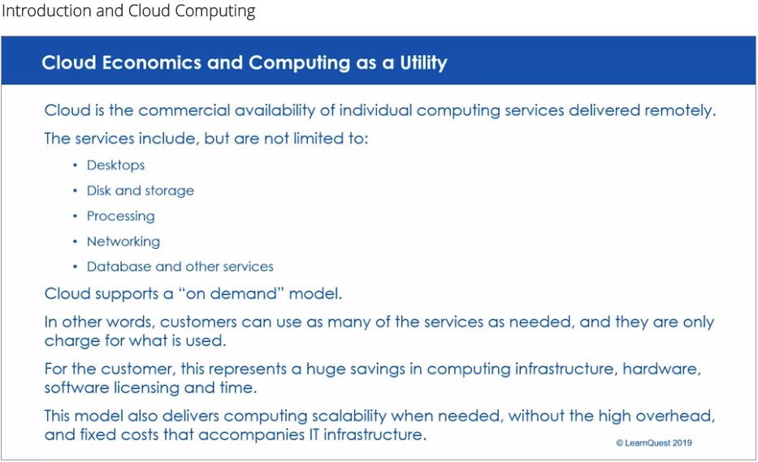

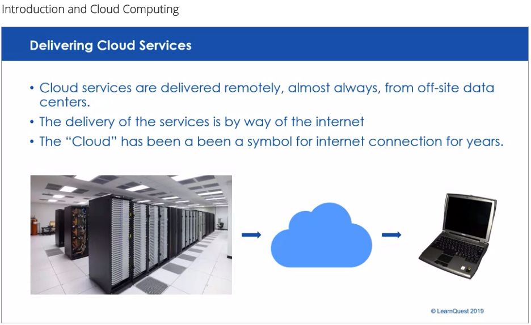

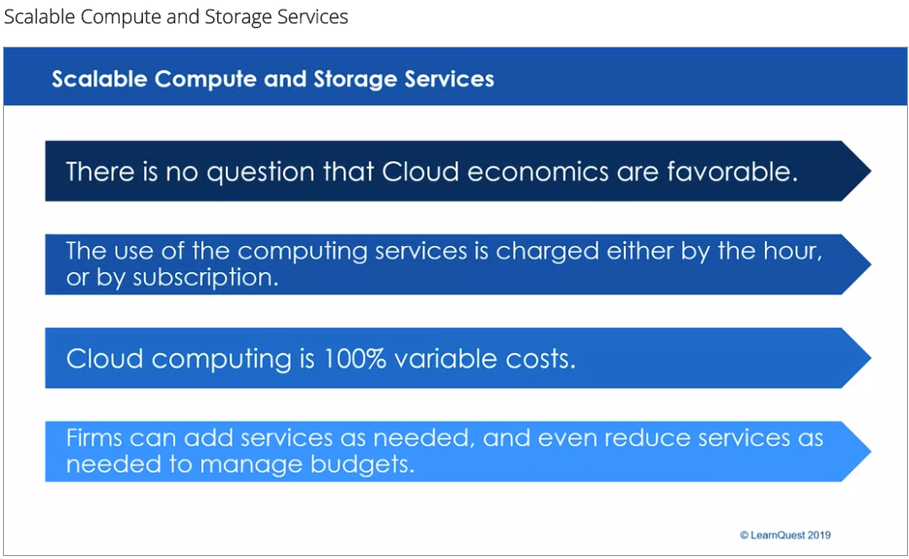

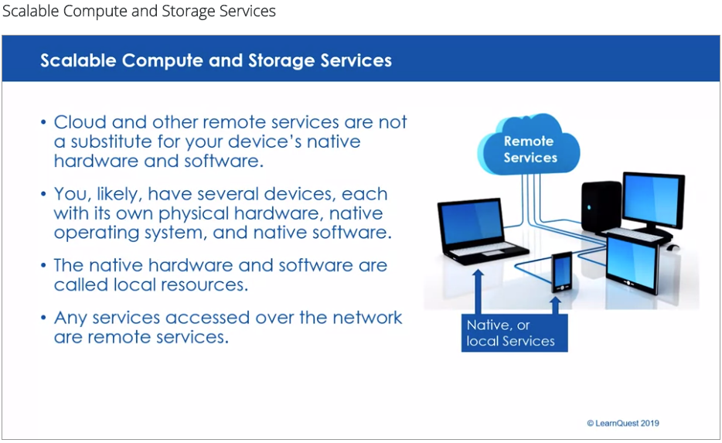

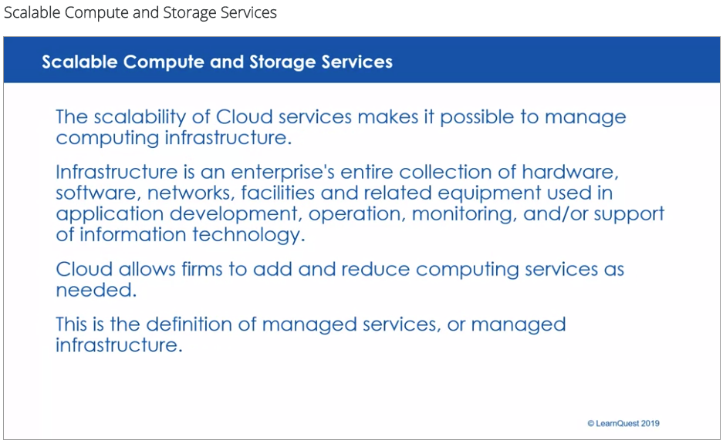

**Scalable Cloud Computing and Storage Services**

Scalable computing and storage services is an offering of Cloud computing. Virtualization makes it possible to scale up computing resources on-demand. This allows forms to add new computing resources just when they need it, and manage costs. The same is true for storage. Cloud makes it possible for firms to obtain more disk for storage, when it is needed.

Simply put, cloud computing is the delivery of computing services—including servers, storage, databases, networking, software, analytics, and intelligence—over the Internet (“the cloud”) to offer faster innovation, flexible resources, and economies of scale. You typically pay only for cloud services you use, helping you lower your operating costs, run your infrastructure more efficiently, and scale as your business needs change.

* **Top benefits of cloud computing**

Cloud computing is a big shift from the traditional way businesses think about IT resources. Here are seven common reasons organizations are turning to cloud computing services:

**Cost:** Cloud computing eliminates the capital expense of buying hardware and software and setting up and running on-site datacenters—the racks of servers, the round-the-clock electricity for power and cooling, and the IT experts for managing the infrastructure. It adds up fast.

**Speed:** Most cloud computing services are provided self service and on demand, so even vast amounts of computing resources can be provisioned in minutes, typically with just a few mouse clicks, giving businesses a lot of flexibility and taking the pressure off capacity planning.

**Global scale:** The benefits of cloud computing services include the ability to scale elastically. In cloud speak, that means delivering the right amount of IT resources—for example, more or less computing power, storage, bandwidth—right when they’re needed, and from the right geographic location.

**Productivity:** On-site datacenters typically require a lot of “racking and stacking”—hardware setup, software patching, and other time-consuming IT management chores. Cloud computing removes the need for many of these tasks, so IT teams can spend time on achieving more important business goals.

**Performance:** The biggest cloud computing services run on a worldwide network of secure datacenters, which are regularly upgraded to the latest generation of fast and efficient computing hardware. This offers several benefits over a single corporate datacenter, including reduced network latency for applications and greater economies of scale.

**Reliability:** Cloud computing makes data backup, disaster recovery, and business continuity easier and less expensive because data can be mirrored at multiple redundant sites on the cloud provider’s network.

**Security:** Many cloud providers offer a broad set of policies, technologies, and controls that strengthen your security posture overall, helping protect your data, apps, and infrastructure from potential threats.

* **Types of cloud computing**

Not all clouds are the same and not one type of cloud computing is right for everyone. Several different models, types, and services have evolved to help offer the right solution for your needs.

First, you need to determine the type of cloud deployment, or cloud computing architecture, that your cloud services will be implemented on. There are three different ways to deploy cloud services: on a public cloud, private cloud, or hybrid cloud.

**Public cloud**

Public clouds are owned and operated by a third-party cloud service providers, which deliver their computing resources, like servers and storage, over the Internet. Microsoft Azure is an example of a public cloud. With a public cloud, all hardware, software, and other supporting infrastructure is owned and managed by the cloud provider. You access these services and manage your account using a web browser.

**Private cloud**

A private cloud refers to cloud computing resources used exclusively by a single business or organization. A private cloud can be physically located on the company’s on-site datacenter. Some companies also pay third-party service providers to host their private cloud. A private cloud is one in which the services and infrastructure are maintained on a private network.

**Hybrid cloud**

Hybrid clouds combine public and private clouds, bound together by technology that allows data and applications to be shared between them. By allowing data and applications to move between private and public clouds, a hybrid cloud gives your business greater flexibility, more deployment options, and helps optimize your existing infrastructure, security, and compliance.

* **Types of cloud services: IaaS, PaaS, serverless, and SaaS**

Most cloud computing services fall into four broad categories: infrastructure as a service (IaaS), platform as a service (PaaS), serverless, and software as a service (SaaS). These are sometimes called the cloud computing "stack" because they build on top of one another. Knowing what they are and how they’re different makes it easier to accomplish your business goals.

Infrastructure as a service (IaaS)

The most basic category of cloud computing services. With IaaS, you rent IT infrastructure—servers and virtual machines (VMs), storage, networks, operating systems—from a cloud provider on a pay-as-you-go basis.

Infrastructure as a service (IaaS) is an instant computing infrastructure, provisioned and managed over the internet. It’s one of the four types of cloud services, along with software as a service (SaaS), platform as a service (PaaS), and serverless.

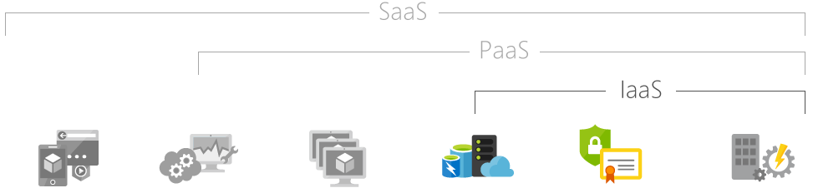

IaaS quickly scales up and down with demand, letting you pay only for what you use. It helps you avoid the expense and complexity of buying and managing your own physical servers and other datacenter infrastructure. Each resource is offered as a separate service component, and you only need to rent a particular one for as long as you need it. A cloud computing service provider, such as Azure, manages the infrastructure, while you purchase, install, configure, and manage your own software—operating systems, middleware, and applications.

* **Common IaaS business scenarios**

Typical things businesses do with IaaS include:

1. Test and development. Teams can quickly set up and dismantle test and development environments, bringing new applications to market faster. IaaS makes it quick and economical to scale up dev-test environments up and down.
2. Website hosting. Running websites using IaaS can be less expensive than traditional web hosting.
3. Storage, backup, and recovery. Organizations avoid the capital outlay for storage and complexity of storage management, which typically requires a skilled staff to manage data and meet legal and compliance requirements. IaaS is useful for handling unpredictable demand and steadily growing storage needs. It can also simplify planning and management of backup and recovery systems.
4. Web apps. IaaS provides all the infrastructure to support web apps, including storage, web and application servers, and networking resources. Organizations can quickly deploy web apps on IaaS and easily scale infrastructure up and down when demand for the apps is unpredictable.
5. High-performance computing. High-performance computing (HPC) on supercomputers, computer grids, or computer clusters helps solve complex problems involving millions of variables or calculations. Examples include earthquake and protein folding simulations, climate and weather predictions, financial modeling, and evaluating product designs.
6. Big data analysis. Big data is a popular term for massive data sets that contain potentially valuable patterns, trends, and associations. Mining data sets to locate or tease out these hidden patterns requires a huge amount of processing power, which IaaS economically provides.

**Platform as a service (PaaS)**

Platform as a service refers to cloud computing services that supply an on-demand environment for developing, testing, delivering, and managing software applications. PaaS is designed to make it easier for developers to quickly create web or mobile apps, without worrying about setting up or managing the underlying infrastructure of servers, storage, network, and databases needed for development.

Platform as a service (PaaS) is a complete development and deployment environment in the cloud, with resources that enable you to deliver everything from simple cloud-based apps to sophisticated, cloud-enabled enterprise applications. You purchase the resources you need from a cloud service provider on a pay-as-you-go basis and access them over a secure Internet connection.

Like IaaS, PaaS includes infrastructure—servers, storage, and networking—but also middleware, development tools, business intelligence (BI) services, database management systems, and more. PaaS is designed to support the complete web application lifecycle: building, testing, deploying, managing, and updating.

PaaS allows you to avoid the expense and complexity of buying and managing software licenses, the underlying application infrastructure and middleware, container orchestrators such as Kubernetes, or the development tools and other resources. You manage the applications and services you develop, and the cloud service provider typically manages everything else.

* **Common PaaS scenarios**

Organizations typically use PaaS for these scenarios:

1. Development framework. PaaS provides a framework that developers can build upon to develop or customize cloud-based applications. Similar to the way you create an Excel macro, PaaS lets developers create applications using built-in software components. Cloud features such as scalability, high-availability, and multi-tenant capability are included, reducing the amount of coding that developers must do.
2. Analytics or business intelligence. Tools provided as a service with PaaS allow organizations to analyze and mine their data, finding insights and patterns and predicting outcomes to improve forecasting, product design decisions, investment returns, and other business decisions.
3. Additional services. PaaS providers may offer other services that enhance applications, such as workflow, directory, security, and scheduling.

**Advantages of PaaS**

By delivering infrastructure as a service, PaaS offers the same advantages as IaaS. But its additional features—middleware, development tools, and other business tools—give you more advantages:

1. Cut coding time. PaaS development tools can cut the time it takes to code new apps with pre-coded application components built into the platform, such as workflow, directory services, security features, search, and so on.
2. Add development capabilities without adding staff. Platform as a Service components can give your development team new capabilities without your needing to add staff having the required skills.
3. Develop for multiple platforms—including mobile—more easily. Some service providers give you development options for multiple platforms, such as computers, mobile devices, and browsers making cross-platform apps quicker and easier to develop.
4. Use sophisticated tools affordably. A pay-as-you-go model makes it possible for individuals or organizations to use sophisticated development software and business intelligence and analytics tools that they could not afford to purchase outright.
5. Support geographically distributed development teams. Because the development environment is accessed over the Internet, development teams can work together on projects even when team members are in remote locations.
6. Efficiently manage the application lifecycle. PaaS provides all of the capabilities that you need to support the complete web application lifecycle: building, testing, deploying, managing, and updating within the same integrated environment.

**Serverless computing**

Overlapping with PaaS, serverless computing focuses on building app functionality without spending time continually managing the servers and infrastructure required to do so. The cloud provider handles the setup, capacity planning, and server management for you. Serverless architectures are highly scalable and event-driven, only using resources when a specific function or trigger occurs.

Serverless computing enables developers to build applications faster by eliminating the need for them to manage infrastructure. With serverless applications, the cloud service provider automatically provisions, scales, and manages the infrastructure required to run the code.

In understanding the definition of serverless computing, it’s important to note that servers are still running the code. The serverless name comes from the fact that the tasks associated with infrastructure provisioning and management are invisible to the developer. This approach enables developers to increase their focus on the business logic and deliver more value to the core of the business. Serverless computing helps teams increase their productivity and bring products to market faster, and it allows organizations to better optimize resources and stay focused on innovation.

**Software as a service (SaaS)**

Software as a service is a method for delivering software applications over the Internet, on demand and typically on a subscription basis. With SaaS, cloud providers host and manage the software application and underlying infrastructure, and handle any maintenance, like software upgrades and security patching. Users connect to the application over the Internet, usually with a web browser on their phone, tablet, or PC.

Software as a service (SaaS) allows users to connect to and use cloud-based apps over the Internet. Common examples are email, calendaring, and office tools (such as Microsoft Office 365).

SaaS provides a complete software solution that you purchase on a pay-as-you-go basis from a cloud service provider. You rent the use of an app for your organization, and your users connect to it over the Internet, usually with a web browser. All of the underlying infrastructure, middleware, app software, and app data are located in the service provider’s data center. The service provider manages the hardware and software, and with the appropriate service agreement, will ensure the availability and the security of the app and your data as well. SaaS allows your organization to get quickly up and running with an app at minimal upfront cost.

* **Common SaaS scenarios**

If you’ve used a web-based email service such as Outlook, Hotmail, or Yahoo! Mail, then you’ve already used a form of SaaS. With these services, you log into your account over the Internet, often from a web browser. The email software is located on the service provider’s network, and your messages are stored there as well. You can access your email and stored messages from a web browser on any computer or Internet-connected device.

The previous examples are free services for personal use. For organizational use, you can rent productivity apps, such as email, collaboration, and calendaring; and sophisticated business applications such as customer relationship management (CRM), enterprise resource planning (ERP), and document management. You pay for the use of these apps by subscription or according to the level of use.

* **Advantages of SaaS**

1. Gain access to sophisticated applications. To provide SaaS apps to users, you don’t need to purchase, install, update, or maintain any hardware, middleware, or software. SaaS makes even sophisticated enterprise applications, such as ERP and CRM, affordable for organizations that lack the resources to buy, deploy, and manage the required infrastructure and software themselves.
2. Pay only for what you use. You also save money because the SaaS service automatically scales up and down according to the level of usage.
3. Use free client software. Users can run most SaaS apps directly from their web browser without needing to download and install any software, although some apps require plugins. This means that you don’t need to purchase and install special software for your users.
4. Mobilize your workforce easily. SaaS makes it easy to “mobilize” your workforce because users can access SaaS apps and data from any Internet-connected computer or mobile device. You don’t need to worry about developing apps to run on different types of computers and devices because the service provider has already done so. In addition, you don’t need to bring special expertise onboard to manage the security issues inherent in mobile computing. A carefully chosen service provider will ensure the security of your data, regardless of the type of device consuming it.
5. Access app data from anywhere. With data stored in the cloud, users can access their information from any Internet-connected computer or mobile device. And when app data is stored in the cloud, no data is lost if a user’s computer or device fails.

**Uses of cloud computing**

You’re probably using cloud computing right now, even if you don’t realize it. If you use an online service to send email, edit documents, watch movies or TV, listen to music, play games, or store pictures and other files, it’s likely that cloud computing is making it all possible behind the scenes. The first cloud computing services are barely a decade old, but already a variety of organizations—from tiny startups to global corporations, government agencies to non-profits—are embracing the technology for all sorts of reasons.

Here are a few examples of what’s possible today with cloud services from a cloud provider:

* **Create cloud-native applications**

Quickly build, deploy, and scale applications—web, mobile, and API. Take advantage of cloud-native technologies and approaches, such as containers, Kubernetes, microservices architecture, API-driven communication, and DevOps.

* **Test and build applications**

Reduce application development cost and time by using cloud infrastructures that can easily be scaled up or down.

* **Store, back up, and recover data**

Protect your data more cost-efficiently—and at massive scale—by transferring your data over the Internet to an offsite cloud storage system that’s accessible from any location and any device.

* **Analyze data**

Unify your data across teams, divisions, and locations in the cloud. Then use cloud services, such as machine learning and artificial intelligence, to uncover insights for more informed decisions.

* **Stream audio and video**

Connect with your audience anywhere, anytime, on any device with high-definition video and audio with global distribution.

* **Embed intelligence**

Use intelligent models to help engage customers and provide valuable insights from the data captured.

* **Deliver software on demand**

Also known as software as a service (SaaS), on-demand software lets you offer the latest software versions and updates around to customers—anytime they need, anywhere they are.